DHPoly

Use-Case Specification: Trading

Version 1.0

Revision History

|  |  |  |  |
| --- | --- | --- | --- |
| **Date** | **Version** | **Description** | **Author** |
| 03.11.2017 | 1.0 | Creation | Sven Köhler |
| 12.11.2017 | 1.1 | Adding .feature File | Sven Köhler |
| 15.11.2017 | 1.1 | Refined UCD | Sven Köhler |
|  |  |  |  |

Use-Case Specification: Trading

# Trading

## Brief Description

This Use-Case called “Trading” describes the trading process between two players in our game.

# Flow of Events

## Basic Flow

<https://github.com/koehler1000/DHpoly/blob/master/diagrams/Trading_UCD.png>

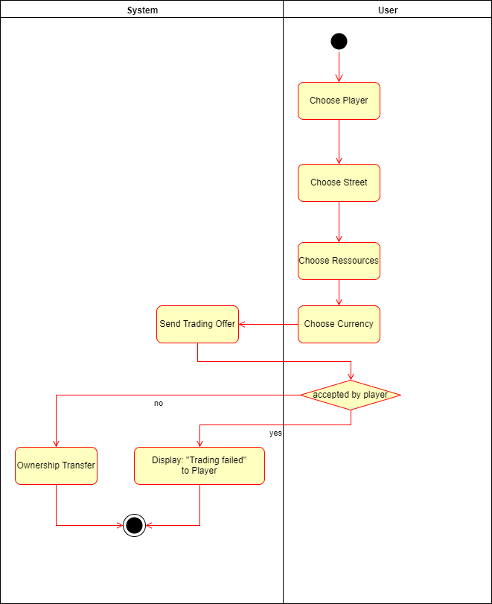

.feature File: <https://github.com/koehler1000/DHpoly/blob/master/cucumber-test/trading.feature>

# Preconditions

It has to be the turn of the player who wants to trade with another player.

# Postconditions

After this Use-Case is finished, there are two possible endings. One is that the trading was successful, the other is that the trading failed. But no matter what case occurred, the game continues after the trading finished.

# Visual Output

